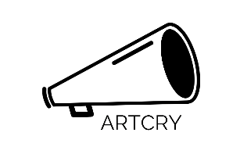
ARTCRY WEBSITE INFORMATION

This is a large print copy of the text on the homepage of ARTCRY’s website.

HOMEPAGE

ARTCRY is a new fund supporting urgent artistic responses to current social and political events.

We need artists who can shine a light and startle some sense into the world with radical, inspiring ideas. ARTCRY is a new fund which aims to encourage artists to create bold political work with fast-turnaround funding which enables fast action.
​
We need your support to make this happen.

We will fund small grants with a panel of artists, activists, creators and producers making decisions on applications within a week.

We are interested in funding work which responds to events happening now and need funding immediately to make that possible.
​
In a climate where 48 hours makes a headline old news and distraction politics are commonplace, we need to be able to respond faster.
​
Artistic responses can challenge a narrative, provoke deeper conversation or capture the mood of a community in the moment.
In astonishing times, we need to be able to respond more bravely and nimbly. Before the lockdown it was increasingly difficult for artists and organisations to take risks and make work responsively, now it's even harder. Artistic responses which cut through the noise are needed and we need to encourage and support each other to do it.

Support ARTCRY

ARTCRY doesn’t have a pot of funding, it relies on individuals getting behind it and supporting the idea to become a reality. 100% of all donations will go directly to artists.
​
Together we can make a difference.
​
It’s important we CRY OUT.

DONATE HERE [link www.crowdfunder.co.uk/artcry]
Thank you

If you want to stay in touch with the project please email Kathryn Bilyard on kathryn@artcry.co.uk

