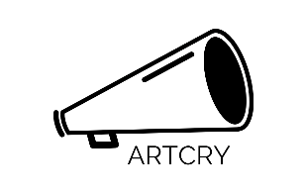
ARTCRY WEBSITE INFORMATION

This is a large print copy of the text on the homepage of ARTCRY’s website.

HOMEPAGE

ARTCRY supports fast response political artworks in public space.

We need artists who can shine a light and startle some sense into the world with radical, inspiring ideas. ARTCRY funds and supports artists to create bold political work with funding in seven days to enable fast action.

A panel of artists, activists, creatives and producers make decisions on applications within seven days.

We are interested in funding work which responds to events happening now and need funding immediately to make that possible.

​

In a climate where 48 hours makes a headline old news, distraction politics are commonplace and opinions are formed after two sentences we need to be able to respond faster.

Artistic responses can challenge a narrative, provoke deeper conversation, hold nuance and contradiction or capture the mood of a community in the moment.

In these times, we need to be able to respond more bravely and nimbly. Before the lockdown it was increasingly difficult for artists and organisations to take risks and make work responsively, now it's even harder. Artistic responses which cut through the noise are needed and we need to encourage and support each other to do it.

Support ARTCRY
ARTCRY relies on funding from individuals, organisations and trusts. 100% of all donations will go directly to artists.

Together we can make a difference.

It’s important we CRY OUT.

DONATE HERE [LINK: https://www.paypal.com/donate?hosted_button_id=2U8M7B7H6N79U&source=url]
Thank you

Would you like to stay in touch with the project? Then please sign up to our mailing list.

